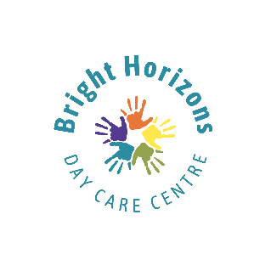**Bright Horizons Daycare Centre (Leuchars)**

Bright Horizons Daycare Centre at Leuchars currently have places available for children (Military and civilian) aged between 6 months and 5 years.

Our daily rate of £52.00 for a full day and £28.00 for a half day ensures we provide an affordable wrap around childcare option for you and your family.

In addition, Bright Horizons will provide you with:

* An Early Years setting that nurtures young minds with

engaging activities, enriching experiences and a curriculum designed to inspire.

* A day care centre that provides a warm, safe and

joyful place for your child to grow, develop and thrive.

* A nursery that provides excellent learning

opportunities for your child with qualified, professional, caring staff who have your child’s best interests at heart.

If you would like more information regarding a place at Bright Horizons, please contact the Manager, Kelly Wall, on (01334) 838439 or email the Centre at [Info@brighthorizonsdaycarecentre.co.uk](mailto:Info@brighthorizonsdaycarecentre.co.uk)